Ethics Agreement

As a responsible servant to all mankind I agree to:
- Maintain a meaningful, personal relationship with God, my Father through Jesus Christ.
- Maintain a personal life of prayer, Bible study, meditation, and personal development.
- Maintain a commitment to the written Word of God as an expression of the Lordship of Jesus.
- Maintain a personal passion to serve God and help others by continually developing my interpersonal skills.
- Maintain a lifestyle that in no way brings reproach to God or the Heart Physics® Program, results in inferior service, or constitutes a violation of any local, state, or federal laws in the application of these tools and resources.
- Maintain a professional, ethical relationship with all people served and to refer them promptly when unable to do so.
- Maintain annual certification renewals through continuing education and ongoing personal development.
- Believe in and promote the dignity and worth of every individual served.
- Believe, live, demonstrate, and promote the message of grace, peace, and love of God.
- Present these tools and resources in a responsible manner and in such a way that does not result in an excuse for destructive living.
- Never withhold good from any individual when it is possible to provide service.
- Provide services using the tools and resources that are relevant to the needs of each individual served regardless of direct benefit or personal gain.
- Encourage every individual to pursue their dreams and goals regardless of any personal benefit.
- Avoid all forms of control, manipulation, abuse, and codependent behavior.
- Avoid making direct, indirect, or exaggerated claims regarding professional qualifications or quality of services offered that exceed education, training, experience, professional affiliation, certification, and ordination qualifications.
- Contribute my ideas and findings to the general body of knowledge for the benefit of others.

- Adhere strictly to the rules of confidentiality of all records, material, and knowledge and to only share such knowledge with individuals who can aid in the progress of those being served and only as law and ethics allow.
- Respect the integrity of other therapeutic approaches, make efforts to build bridges, and develop collaborative relationships to achieve the best possible ministry for all people.
- Handle fiduciary responsibilities with the utmost integrity.
- Surrender all Heart Physics® certificates in the event that my credentials are revoked.
Please read and seriously consider these statements. If you accept these ethical standards, please sign this agreement, make a copy for yourself, and return the original with your application.

Print Name: _______________________________________________

Signature: _________________________________________________

Date: _____________________________________________________

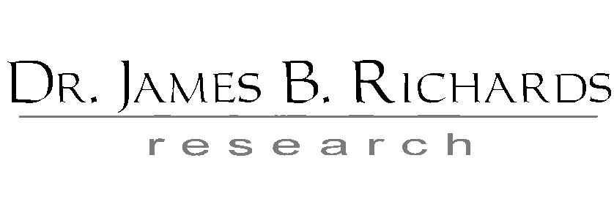
3516 S. Broad Place * Huntsville, AL 35805 * 256.536.9402

